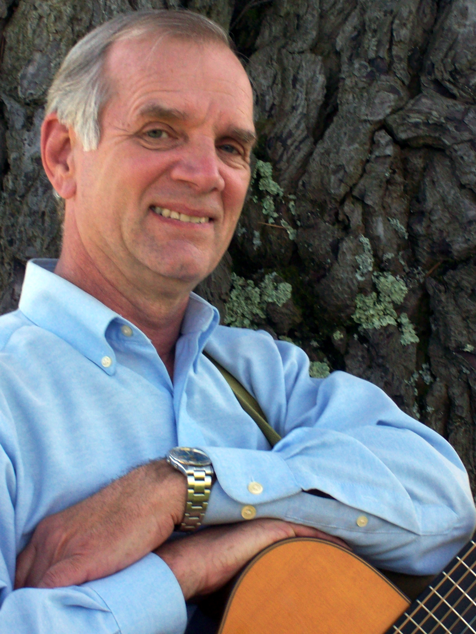
Rick Dougherty

Rick Dougherty doesn't remember a time when he didn't sing, and his beautiful tenor voice has garnered him compliments from Judy Collins, Chet Atkins and Tom Paxton, to name just a few. It has also led to a long and wide-ranging career in music. As a youth he performed solo throughout the West, developing a versatile finger-style guitar technique to accompany himself and expanding his repertoire from folk to standards and jazz. He graduated Sonoma State University in 1987 and in the following thirteen years directed 37 operas, and was the arranger for two a cappella groups.

In 1990 he became a member of The Limeliters and performed with them until 2003 when he left the group to sing with Glenn Yarbrough as part of the "This Land Is Your Land" folk tour. At the end of the tour in 2005, he was invited to join The Kingston Trio with whom he performed nationwide until late 2017.

Rick continues to perform across the country and conducts workshops on voice and guitar. He recently published "Sounding Good on One Guitar," a guitar manual for beginning to advanced intermediate players which has received excellent reviews.

He is currently working on a CD which, at the rate things are going, should be finished just before the polar caps melt.

Discography

The Limeliters - Until We Get It Right! (1999)
The Kingston Trio - Born at the Right Time (3/2012)
The Kingston Trio - Bloodlines Hold the Key (8/2017)
The Kingston Trio – Holiday Cheers (11/2017) CD & DVD

Website

RickDoughertyMusic.com

